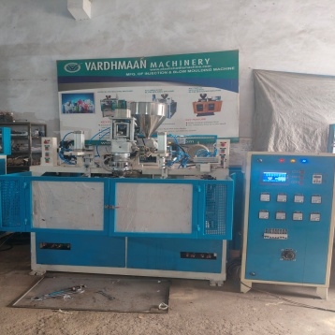R
PRODUCTION CAPACITY
150 PCS./HOUR OF 60 GMS ARTICLE
250 PIECES /HOUR OF 20 GMS ARTICLE
PIECES
VARDHMAN MACHINERY.
72, DEV BHUMI INDUSTRIAL ESTATE, OPP. GPAL CHARAN ESTATE, BAKROL BUJARANG, AHMEDABAD.382430.
CONTACT NO :- 9827266991.
SALES@VARDHMANMACHINE@GMAIL.COM
WEB :- VARDHMANMACHINE.COM

MACHINE SPECIFICATION | UNIT | 1 LITER  TOY
SCREW DIAMETER | MM | 40
PLASTICIZING CAPACITY | KG/CM2 | 8-12
MOULD WIDTH | MM | 150
MOULD LENGTH | MM | 500
SUITABLE PRODUCT | GMS. | 20 TO 70
MOULD SIZE | MM | 150*550
MOULD LENGTH | ML | 20”
MOULD OPENING STROKE | MM | 175
EXTRUDER DRIVE | KW/hp | 2.2/5
HYDRAULIC DRIVE  . | KW/HP | 1.5/2
HEATING LOAD. | KW | 6
TOTAL CONNECTING LOAD | KW/HP | 9.7

APPLICATION :-FOR MAKING BAT , BROOM HANDLE , TOYS.
SUITABLE LENGTH : -20 “
WEIGHT OF PRODUCT :- 20 TO 60 GMS

1 LITER TOY MAKING SINGLE STATION BLOW MOULDING MACHINE.
REFRESH

HYDRAULIC :- YUKEN MAKE
Pic :- ULTRA MAKE 7” COLOUR HMI
Ac drive :-CRMPTON MAKE
PNUMATIC :-JANATICS , MERCURY .
TIEBAR :--SUPER FINISHED
HARDCHROME PLATED
HOT CUTTER- :-
GEAR BOX : - HEAVY DUTY HELICAL GEAR BOX.
HEATER :- CERAMIC HEATER ,
TOOLKIT :- SSR , THERMOCOUPLE SENSOR
ELECTRICAL-SPAREKIT
HANDYTOOL AND PARTS.
CUP AND PUNCH- EXTRA

STANDARD FEATURE.

