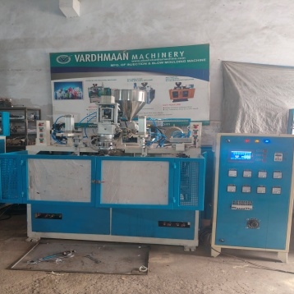Rr

VARDHMAN MACHINERY.
72, DEV BHUMI INDUSTRIAL ESTATE, OPP. GPAL CHARAN ESTATE, BAKROL BUJARANG, AHMEDABAD.382430.
CONTACT NO :- 9827266991.
SALES@VARDHMANMACHINE@GMAIL.COM
Web:- VARDHMANMACHINE.COM

3 LITER TOY MAKING BLOW MOULDING MACHINE
APPLICATION :-FOR MAKING BAT , BROOM HANDLE , TOYS.
SUITABLE LENGTH : - 30”
SUITABLE FOR WEIGHT :- 100 TO 250 GMS
MACHINE SPECIFICATION | UNIT | 3 LITER  TOY
SCREW DIAMETER | MM | 60
PLASTICIZING CAPACITY | KG/CM2 | 25-30
MOULD WIDTH | MM | 225
MOULD LENGTH | MM | 750
SUITABLE PRODUCT | GMS. | 100-250
MOULD SIZE | MM | 225*750
MOULD LENGTH | ML | 30 ”
MOULD OPENING STROKE | MM | 225
EXTRUDER DRIVE | KW/hp | 7.5/10
HYDRAULIC DRIVE  . | KW/HP | 3.7/5
HEATING LOAD. | KW | 11.5
TOTAL CONNECTING LOAD | KW/HP | 22.7

PRODUCTION CAPACITY
90 PCS./HOUR OF 250 GMS ARTICLE
130 PIECES /HOUR OF 100 GMS ARTICLE
PIECES

REFRESHFR

